**Informatica Project**

**Project : 4**

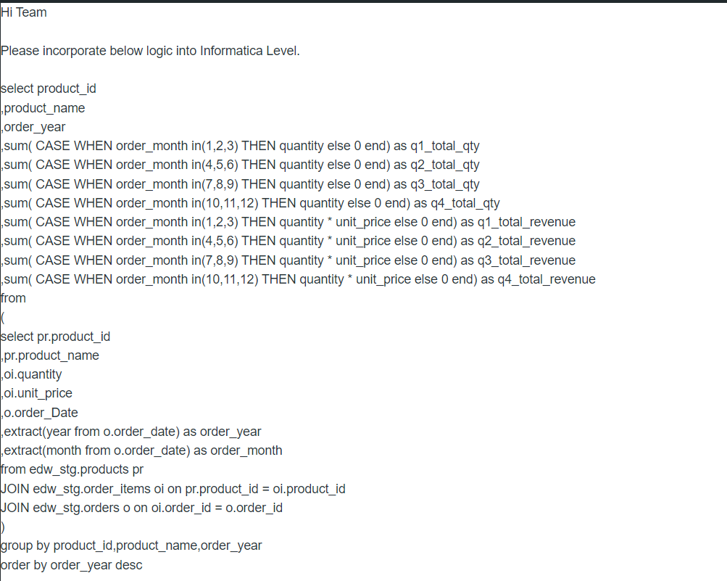

**To find the Revenue of the product for each quarter wise in each year.**

Source Objects: ProductMaster, SaleOrderDetails and SaleOrderHeader Flat File

Target Object: Product_Quarter_Wise_Revenue

To find the total Revenue for each quarter Q1, Q2, Q3 and Q4

Read the Data from three Files Where SaleOrderHeader, SaleOrderDetails and ProductMaster

To find the total quantity and total_Revenue of the each product.

To send the output to Oracle Table with the following structure.

Product_id

product_name

Year = YYYY format (Extract from Order_Date Column)

Q1_Quantity

Q2_Quantity

Q3_Quantity

Q4_Quantity

Q1_Revenue

Q2_Revenue

Q3_Reveue

Q4_Revenue

Where

Q1 = 1,2,3 Months

Q2 = 4,5,6 Months

Q3 = 7,8,9 Months

Q4 = 10,11,12 Months

Solution:

**Source :**

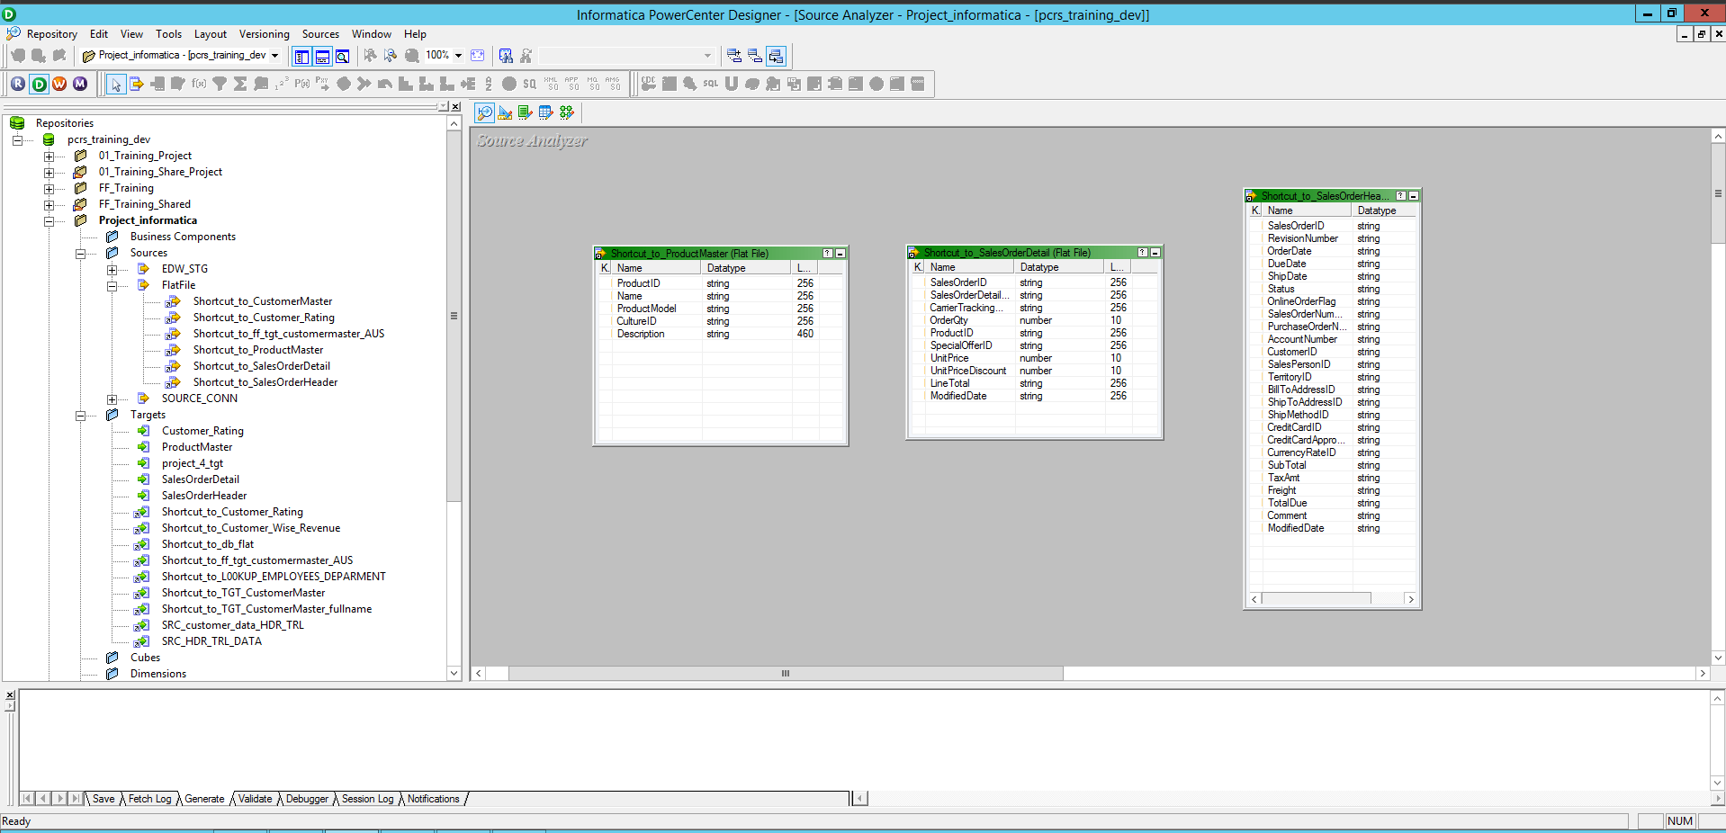

**Target :**

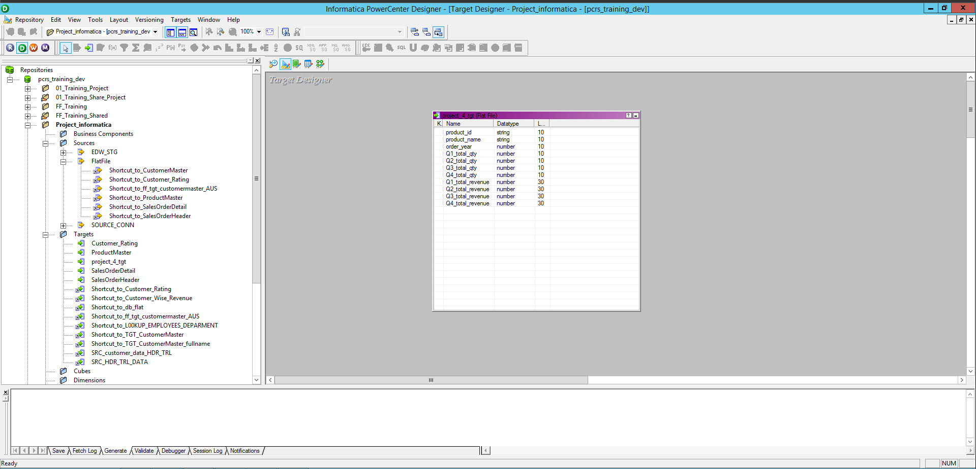

**Mapping :**

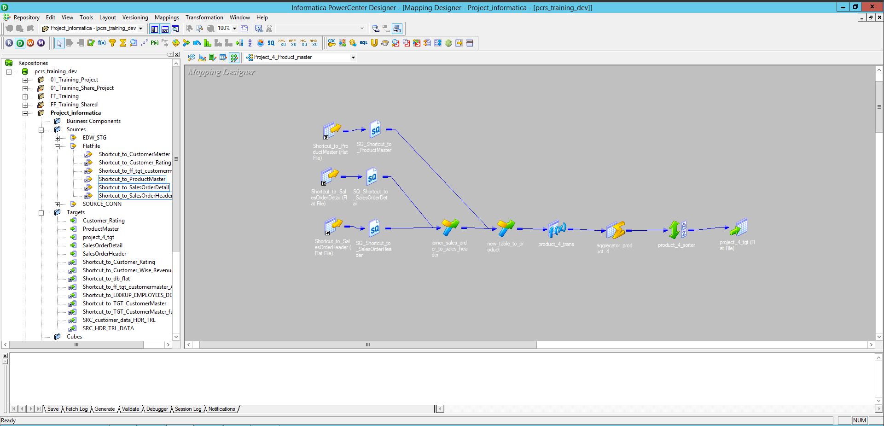

**Workflow:**

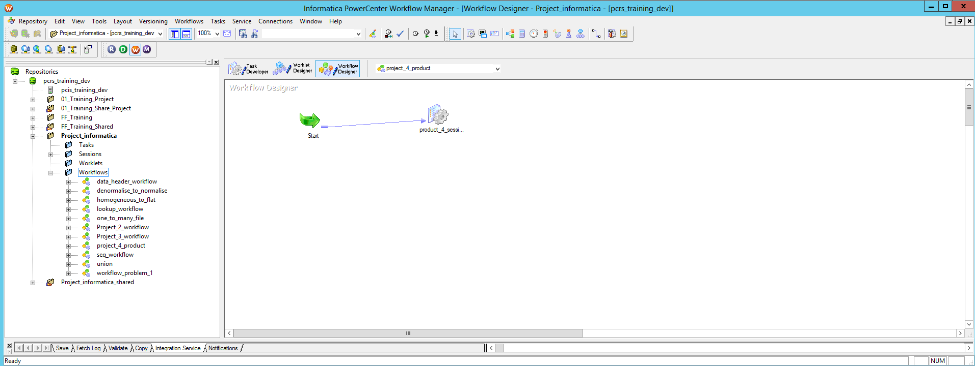

**Monitor:**

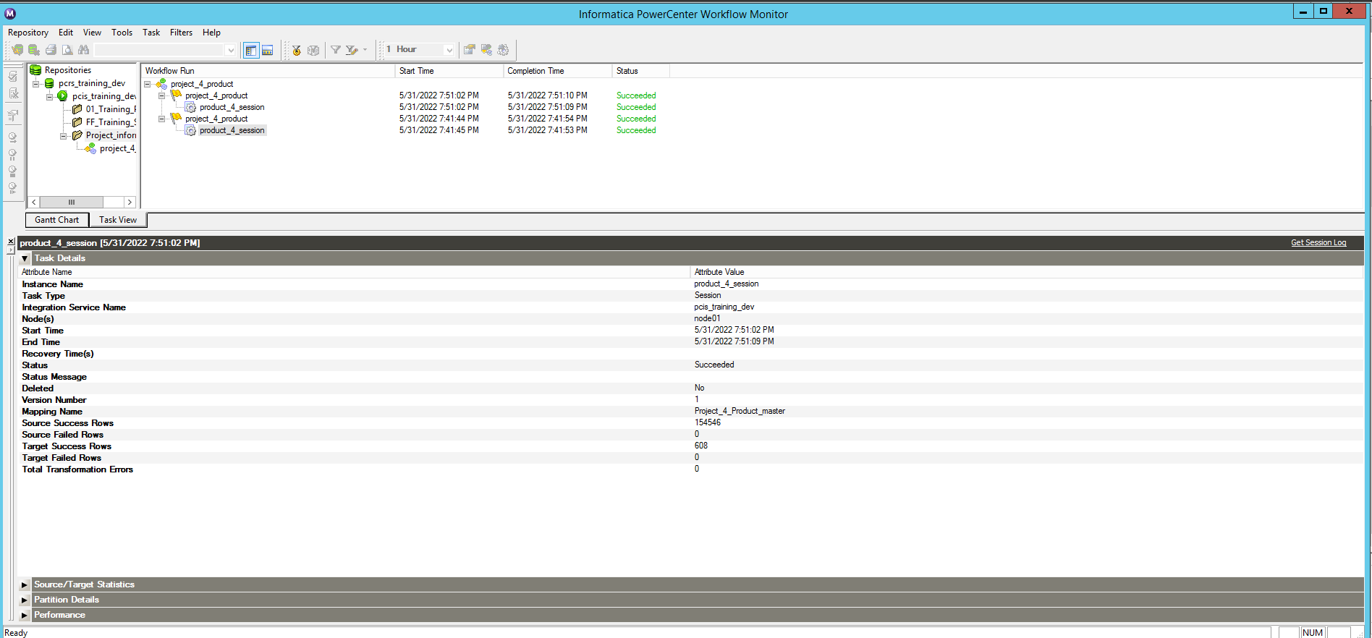

**Output :**

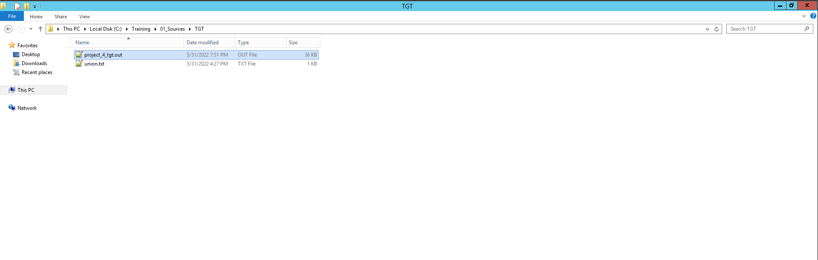

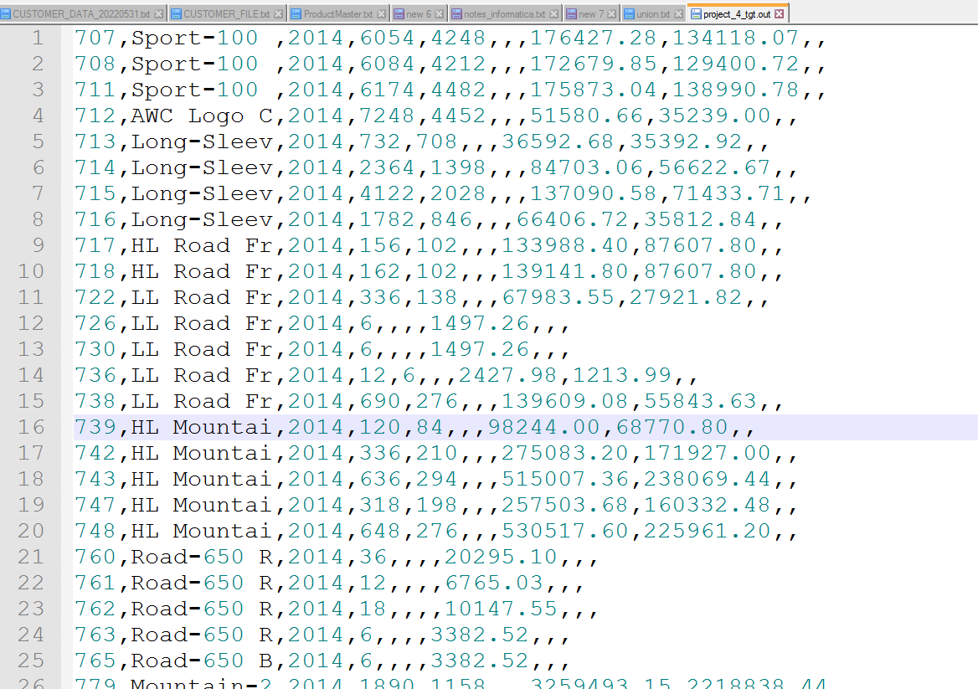

**Project : 5**

I want to remove the duplicate records from source system. Let's take an example, we have customer_master.txt file, we have data like below. I want to remove the duplicate records coming from source and load only unique records to target.

**Hints:** Perform row level operation and remove the dups.

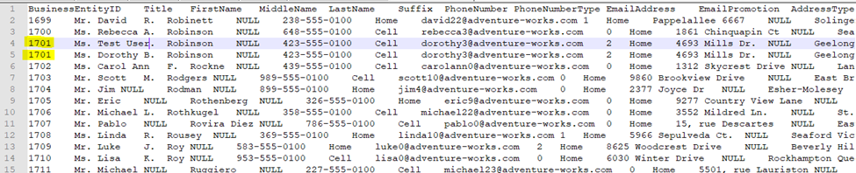

**Solution:**

**Source:**

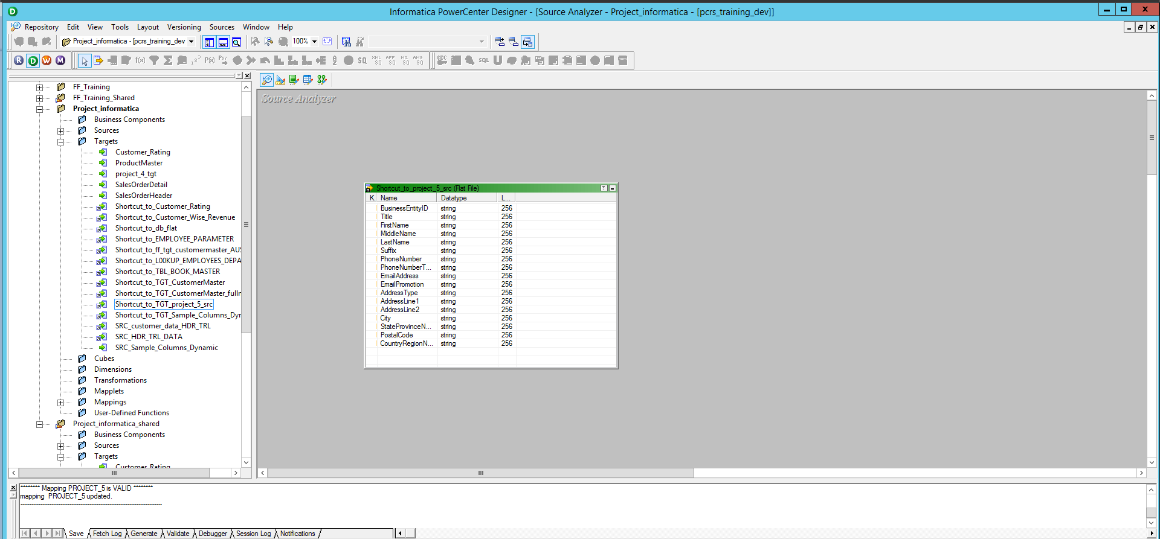

**Target:**

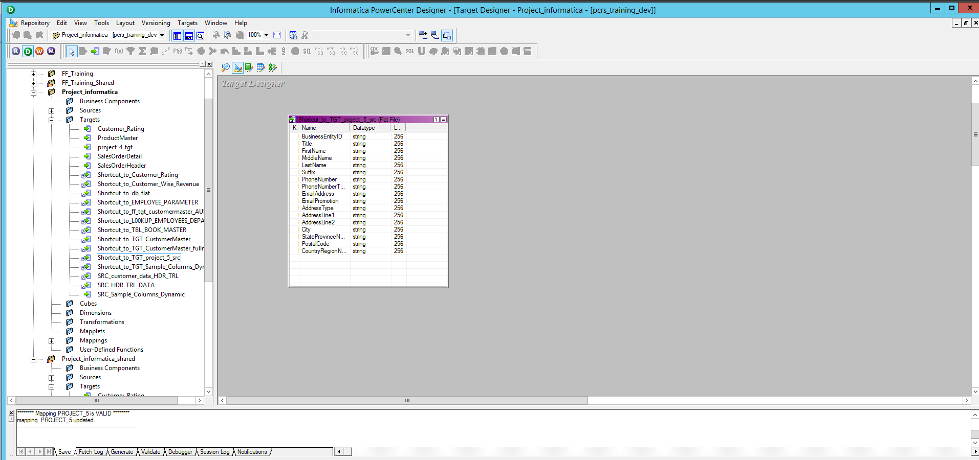

**Mapping:**

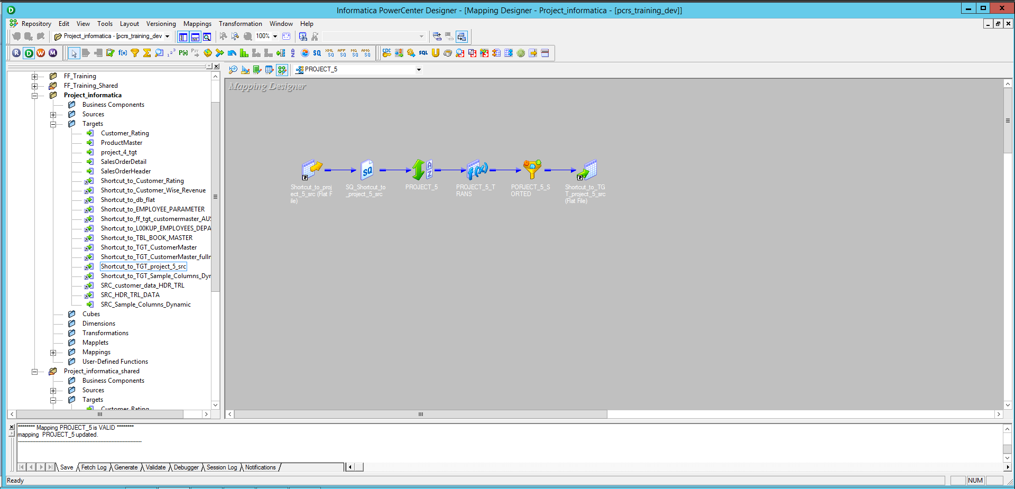

**Workflow:**

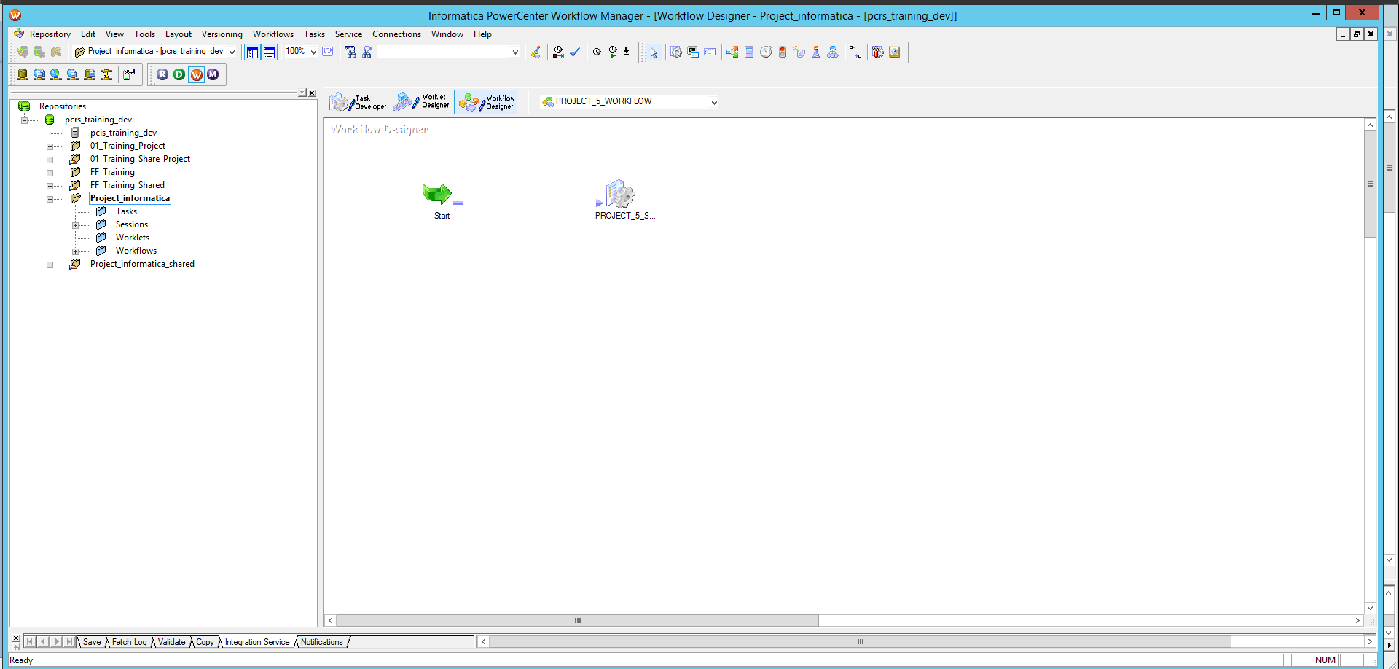

**Monitor:**

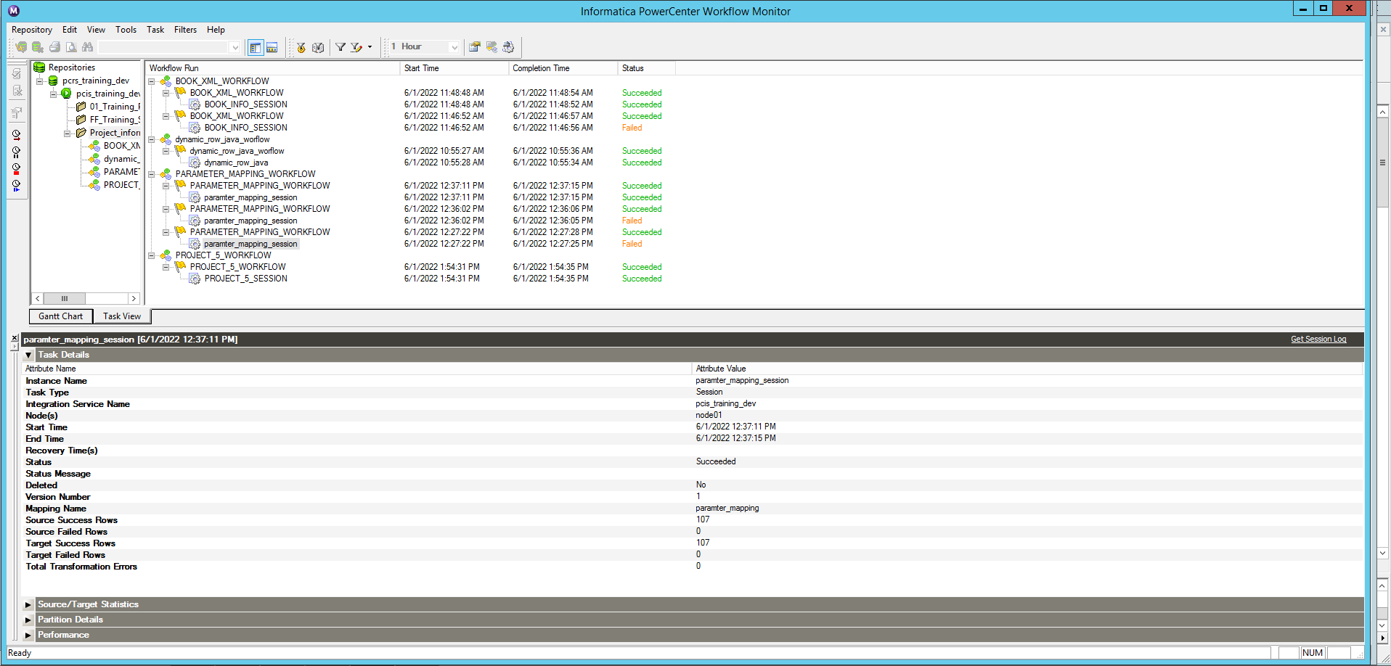

**Output:**

